35.47: a) 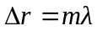
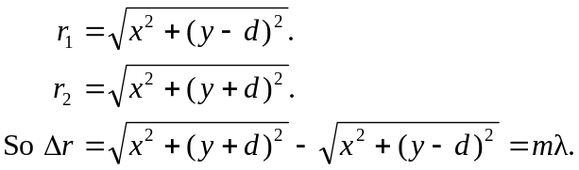
b) The definition of hyperbola is the locus of points such that the difference between 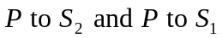is a constant. So, for a given 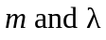 we get a hyperbola. Or, in the case of all for a given , a family of hyperbola.
c) 